**CSS Lab Assignments**

**Q1) Design and Apply style using inline CSS as in the image below.**

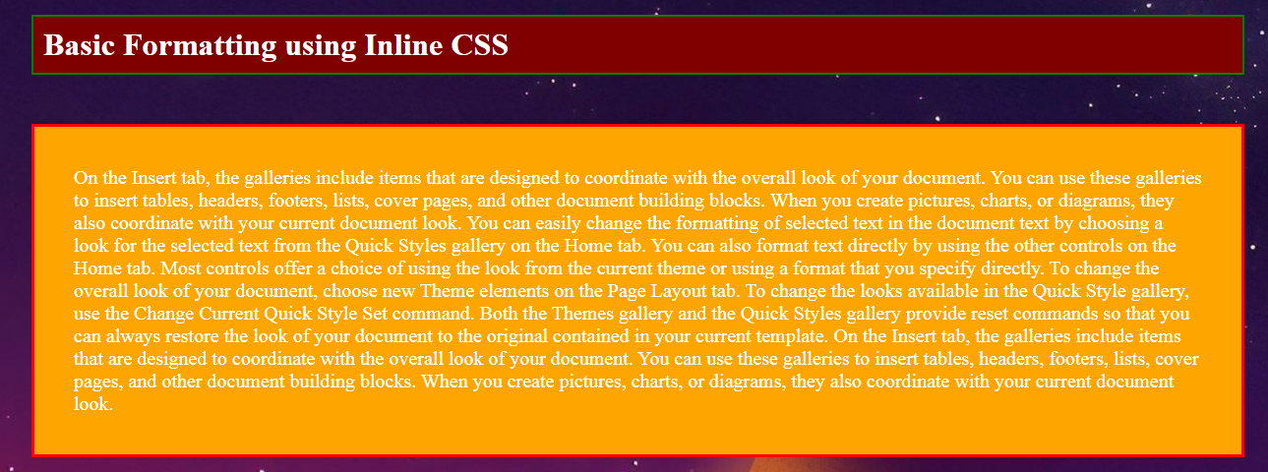

**Q2) Design and Apply style using CSS as in the image below. (Note : Use Div / Table Tag)**

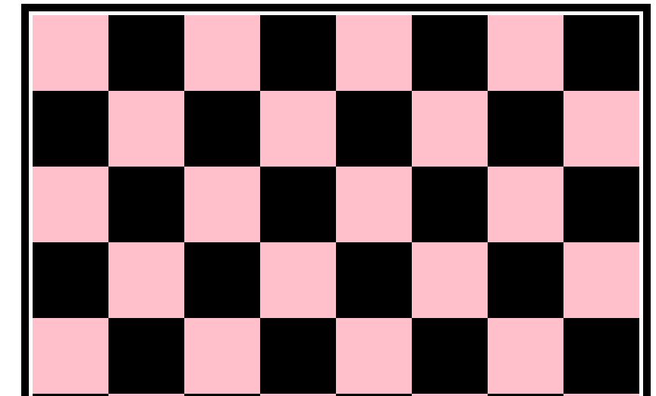

**Q3) Design and Apply style using CSS as in the image below. (Note : Use Internal CSS).**

